Understanding Magazine Subscription Behavior Through Logistic Regression and Support Vector Machine
Allen Gao
University of Massachusetts Amherst
MIE622
Michael Prokle
Introduction
The magazine company is trying to understand last year’s decline in subscriptions. To help them figure out what is working and what is not, a dataset was provided to us to determine the cause by examining customer demographic characteristics, purchasing behavior, and responses to previous marketing campaigns. After the dataset is cleaned and prepared, logistic regression and support vector machine (SVM) models are used to predict whether a customer will accept the latest subscription offer and identify the variables most strongly associated with subscription behavior, along with their potential business implications. The models are then compared using accuracy, precision, and recall, determining which approach would provide the most useful support for the company’s future marketing decisions.
Data Preparation and Cleansing
The first step was to load the dataset into Python using the pandas library. The first five observations were then displayed to verify that the Excel file had been imported correctly and that its columns and values appeared as expected. The dataset was subsequently examined for duplicate observations, missing values, and question-mark placeholders that could represent unrecognized missing data. No duplicate observations or question-mark placeholders were found; however, the Income variable columns were missing several values that needed to be addressed before using it for the model. These missing values were replaced with the median income because the variable contained several outliers that could distort the mean, making the median a more representative measure of a typical customer’s household income.
Several variables were excluded from the dataset because they felt like they did not provide meaningful predictive information. The ID variable was removed because it only serves as a unique identifier for the customer, while Z_CostContact and Z_Revenue were removed because they contain the same value for all of the observations and therefore provided no variation for the model to analyze. Dt_Customer was also removed because it had the raw enrollment date, and converting every unique date into a dummy variable via OneHotEncoding would produce numerous predictors with little practical meaning. This would have unnecessarily increased the models’ complexity without guaranteeing an improvement in predictive performance. Once the unnecessary variables are removed, the categorical columns are then converted to binary dummy variables via the get_dummies function from the pandas library so that they can be processed by the model. After the cleansing and encoding procedures were completed, the dataset was checked again to confirm that no missing values or question-mark placeholders remained.
The target variable, Response, was separated from the remaining dataset and was assigned to y, while the predictor variables were assigned to x. Response indicates whether a customer accepted the latest subscription offer, with 1 representing acceptance and 0 representing rejection. The predictors and target variables were then split into training and test datasets, with 70% of the observation are used to train the model, and the remaining 30% used to evaluate the model. A random state of 42 to make the split reproducible. Before the data were used to train the models, the nonbinary numerical predictors were standardized using StandardScaler. This step is necessary as some of the variables, like income and product spending, have larger numerical ranges than variables such as household counts and purchase frequency. Without standardization, variables with larger ranges would have disproportionate influence on the models, which would make it harder to see which variables are significant and what their impact is. Binary variables, such as Complain and the previous campaign-acceptance indicators, were left unchanged because they were already coded on a consistent scale of 0 and 1, representing yes-and-no conditions.
Logistic Regression Analysis
The LogisticRegression class from the scikit-learn linear_model library was used to train the model with the training predictors. The nonbinary numerical predictors were standardized, while the binary variables remained coded as 0 and 1. The liblinear solver was selected because it is appropriate for binary classification. The logistic regression model achieved a training accuracy of 89.3%, indicating that it correctly classified most of the observations used during training. Although this provided a promising initial result, training accuracy alone was not sufficient to evaluate the model.
Before the model was evaluated using the test data, a logistic regression model from the statsmodels library was fitted to the training data to examine each predictor’s coefficient and p-value. Variables with p-values below 0.05 were considered statistically significant. In the current results, as shown in Figure A1, since there are a lot of significant variables, only the top 5 most significant variables would be discussed to keep it brief. The Together and Married marital-status categories were the two most statistically significant predictors, with coefficients of −4.26 and −4.00, respectively. These negative coefficients tell us customers in these marital status categories are less likely to accept the magazine subscription offer. Also, single marital status has a negative coefficient of -2.97, that make also less likely to accept the magazine subscription offer. Recency has a smaller negative coefficient of -0.85, which means people who haven’t purchased in a long time are unlikely to accept the offer. In contrast, AcceptedCmp3 had a positive coefficient of 1.89, suggesting that customers who accepted the third previous campaign were more likely to accept the latest offer. Based on these findings, the company could prioritize recently active customers and previous campaign responders while developing different marketing approaches for customer groups with lower predicted response rates to get them to accept the subscription offer.
To evaluate the model’s performance on the test dataset, the predict_proba function was used to calculate each customer’s probability of accepting the latest subscription offer. Classification thresholds of 0.40 and 0.80 were evaluated to determine how changing the threshold affected the model’s predictions. At each threshold, customers with predicted probabilities greater than or equal to the threshold were classified as accepting the offer. A confusion matrix and classification report were then generated to evaluate the model’s accuracy, precision, recall, and F1-score. As shown in Figure A2, it seems that a classification threshold of 0.80 was able to perform, as it has an accuracy of 88.2% compared to a classification threshold of 0.40 that only achieved 87.5% accuracy. The classification threshold of 0.80 also produced higher precision but lower recall than the threshold of 0.40. This means that its positive predictions were more reliable, but it failed to identify a greater proportion of customers who actually accepted the subscription offer. It did pretty well predicting of whether or not the customers accepted the subscription offer. There was the thought of using the top 5 most significant predictors only to test the model, but it was dismissed as there are other significant predictors as well, and removing them would hurt the model’s performance.
Support Vector Machine Analysis
The support vector machine was created using a linear kernel. The probability parameter was set to True so that the model could estimate the probability of each customer accepting the subscription offer, allowing different classification thresholds to be evaluated. A random state of 42 was also specified to make the probability-estimation results reproducible. The model was then trained using the training predictors, with the nonbinary numerical variables standardized to prevent variables with larger measurement ranges from having disproportionate influence on the model and their corresponding target variables. The SVM achieved a training accuracy of 89.5%, which was slightly higher than the logistic regression model’s training accuracy of 89.3%. However, this difference of only 0.2 percentage points is too small to conclude that the SVM performed better. Before evaluating the SVM on the test dataset, the coefficients from its linear decision boundary were examined to identify the predictors that had the greatest influence on its classifications.
To examine the predictors and their coefficients, a DataFrame was created using the feature names and the coefficients obtained from the linear SVM. The predictors were sorted from the largest to the smallest absolute coefficient so that the variables with the greatest influence on the model’s decision boundary appeared first. Based on the magnitude of the coefficients, the five most influential predictors were AcceptedCmp5, AcceptedCmp3, AcceptedCmp1, AcceptedCmp4, and AcceptedCmp2, with coefficients of 1.27, 1.19, 0.88, 0.86, and 0.79, respectively. These variables indicate whether a customer accepted an offer from one of the five previous marketing campaigns. Because all five coefficients were positive, previously accepting an offer pushed the SVM’s prediction toward acceptance of the latest subscription offer.
To determine whether these predictors were consistently influential, the permutation_importance function was used as a second measure of feature importance. Each predictor in the test dataset was randomly shuffled 30 times while the remaining predictors were left unchanged. After each shuffle, the model’s F1-score was recalculated. F1-score was selected because it accounts for both precision and recall when evaluating the less common acceptance class. The average decrease in F1-score caused by shuffling each predictor was recorded as its permutation importance. Predictors that produced larger decreases were considered more influential because disrupting their values caused a greater reduction in the model’s performance. The random state of 42 was used so that results were reproducible. The results were sorted from greatest to least importance, and the ten most influential predictors were displayed for comparison with the SVM coefficient rankings.
The permutation-importance result partially supported the coefficient rankings. AcceptedCmp3 and AcceptedCmp5 were the two most influential predictors according to permutation importance, decreasing the model’s F1-score by approximately 0.103 and 0.061 when shuffled. AcceptedCmp1 and AcceptedCmp4 also appeared near the top of both rankings, indicating that responses to previous campaigns consistently influenced the SVM’s predictions. However, the rankings were not identical. Recency had only the eighth-largest absolute coefficient but was the third-most influential variable according to permutation importance. In contrast, AcceptedCmp2 had the fifth-largest coefficient but did not appear among the ten largest permutation-importance values. Overall, the company should focus on more campaigns because the campaign-acceptance variables had the largest SVM coefficients and several also ranked among the most influential variables according to permutation importance. The company could also examine the content and strategies used in those successful campaigns and apply similar approaches to future subscription offers to help more people accept their offers.
The SVM was evaluated on the test dataset using the same procedure applied to the logistic regression model. The model first estimated each customer’s probability of accepting the latest subscription offer. Classification thresholds of 0.40 and 0.80 were then applied to convert these probabilities into predicted classes. Probability estimates were available because the SVM had been initialized with its probability parameter set to True. For each threshold, a confusion matrix and classification report were generated to evaluate the SVM’s accuracy, precision, recall, and F1-score. Using the same test observations, thresholds, and performance metrics allowed the SVM results to be compared fairly with those of the logistic regression model. In the results, as shown in Figure A3, the classification threshold of 0.40 provided overall balance of performance. It achieved an accuracy of 87.9% and a better distribution of precision and recall for class-1 and class-0 compared to the classification threshold of 0.80, where it achieved 87.5%, where it had great precision rate for class-0 and class-1 but a horrible recall rate for class-1, which was only 12%. Therefore, the 0.40 threshold was selected because it provided a more useful balance between identifying potential subscribers and limiting false-negative predictions.
Logistic Regression and SVM Model Performance Comparison
To compare the two models side by side, their predictions at a classification threshold of 0.40 and 0.80 were evaluated using their own test datasets. The accuracy, class-1 precision, and class-1 recall were calculated using their corresponding evaluation functions and organized into a comparison table by the pandas DataFrame, which was displayed as shown in Figure A4. Out of the results in Figure A4, the logistic regression at a 0.80 threshold would be recommended as it provides the best overall balance among the three performance metrics. It achieved the highest accuracy of 88.2%, a good precision rate for class-1 at 86.4%, and a middling recall rate of 20% among the other recall rates. It would be a suitable choice if the company prioritized high overall accuracy and class-1 precision. Across the two models, the predictors that were identified as statistically significant in logistic regression and influential in the SVM included AcceptedCmp1, AcceptedCmp3, AcceptedCmp4, AcceptedCmp5, Recency, and the Together, Single, and Married marital-status categories. AcceptedCmp3, Recency, and Marital_Status_Together appeared particularly important because they ranked near the top of both analyses. Overall, the models indicate that previous campaign responses, recent purchasing activity, and certain marital status are useful for predicting whether a customer will accept the latest subscription offer.
Conclusion
Overall, both logistic regression and the support vector machine performed similarly well, achieving test accuracies between 87.5% and 88.2%. However, their precision and recall differed depending on the classification threshold, demonstrating that model selection should be based on the company’s marketing priorities rather than accuracy alone. The results showed that previous campaign responses, customer recency, and certain marital-status categories were important predictors of subscription acceptance. In particular, customers who accepted earlier campaign offers were more likely to accept the latest offer, while customers whose last purchase occurred longer ago were less likely to respond positively. These findings suggest that the company should prioritize recently active customers and previous campaign responders when developing future subscription campaigns. Marital status may provide additional insight, but it should not be used alone to determine which customers receive an offer. These two models are helpful for the company to identify which customer characteristics and behaviors should be prioritized when planning future marketing campaigns, particularly previous campaign acceptance and recent purchasing activity, so they could increase the number of subscription offers accepted.
Appendix
Figure A1
Statistically Significant Predictors in the Logistic Regression Model
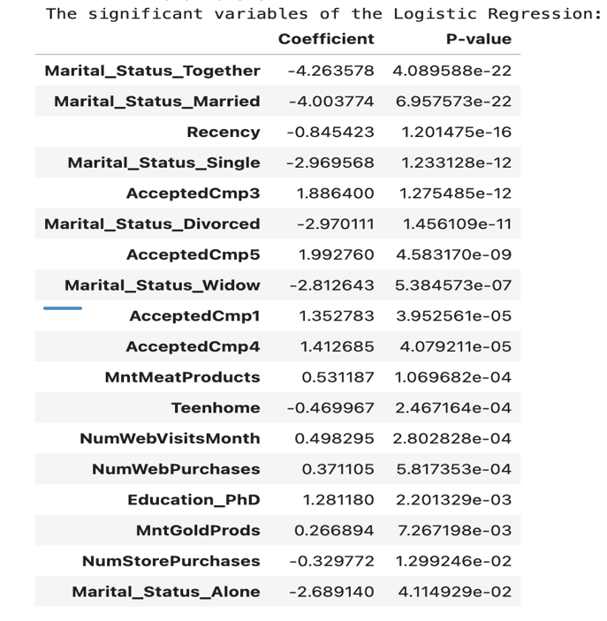
Figure A2
Logistic Regression Performance at Classification Thresholds of 0.40 and 0.80 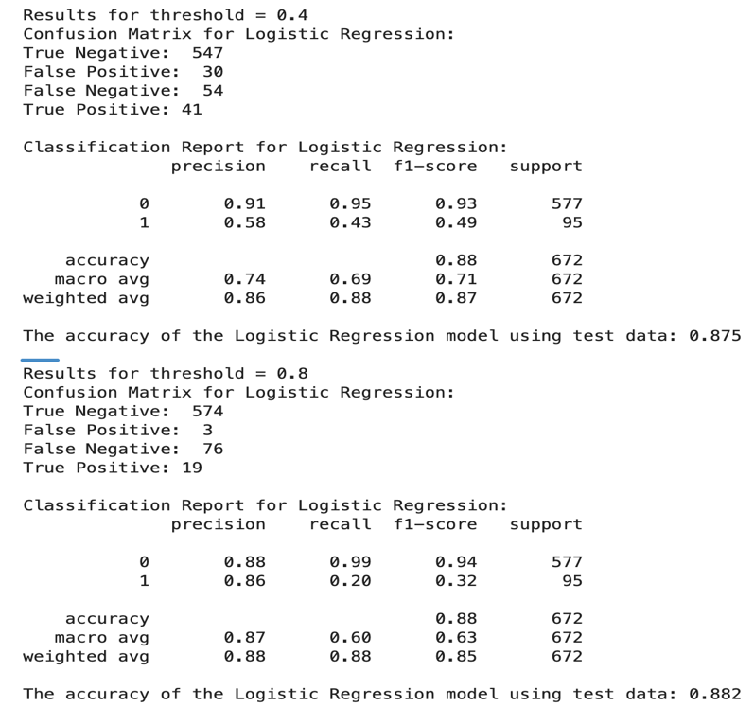
Figure A3
Linear SVM Classification Performance at Thresholds of 0.40 and 0.80
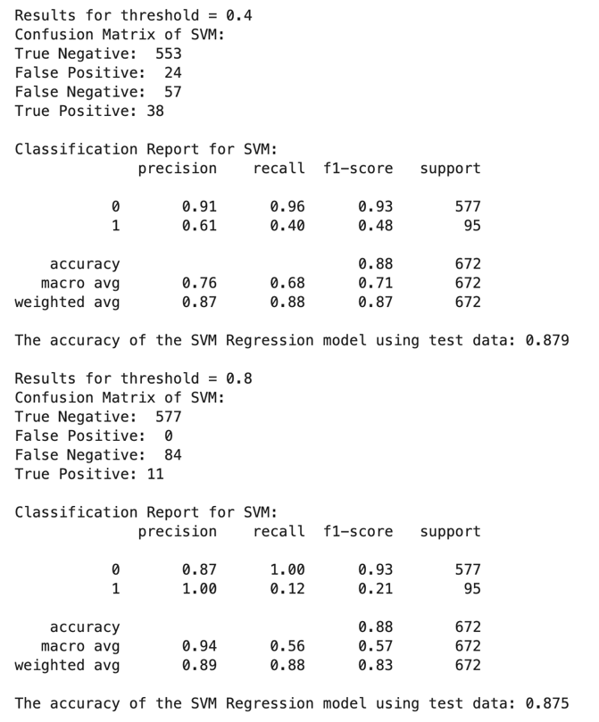
Figure A4
Comparison of Logistic Regression and Linear SVM Performance at Selected Classification Thresholds
